Assignment Sheet 3
Name – Sayak Sen
Enrollment No – 2023CSB047
1.Create a view named as cse_stud for ‘CSE’ dept students having attributes rollno, name,hostel.
create view cse_stud as select rollno, name, hostel from students where deptcode = 'CSE';

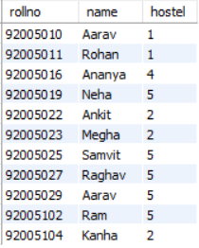
2.Insert a new student of CSE. Analyse the result.
insert into cse_stud values(92005120,'Amit Kumar',3);

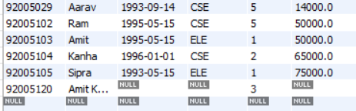
The view does not show the new data, but the original database has it with values as NULL not present in view
3. Increment parental income by Rs. 5000 (HRA).
update students set parent_inc = parent_inc + 5000;
select *from cse_stud;

4. Delete the view.
drop view cse_stud;

5. Create another view of all students in dept Mechanical Engineering (department Name).The view will contain attributes namely Roll-No, Name, Department Name, Age.
create view mech_stud as
select rollno,name,deptcode,year(curdate())-year(bdate) as age
from students
where deptcode = 'MEC';

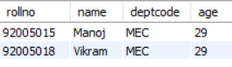

6. Insert a new student of Mechanical Engineering Department.
insert into students values(92005121,'Ravi Shankar','1995-05-12','MEC',2,15000);
select *from mech_stud;

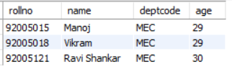
Both original database and view project the changes.
7. Delete a student (for a given Name) of the same department.
delete from students where name = 'Ravi Shankar';
select *from mech_stud;

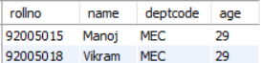
8. Shift a student (for a given Name) from Mechanical to Computer Science.
update students set deptcode = 'CSE' where name = 'Manoj';

